آموزشكده فني گناباد

General English

M.Usefi
Download From : http://www.Dibaa.ir/extrapage/general_english

Pre-reading
1. Could the people travel hundreds of miles each day in the past?
2. Which one is better (live in the future or in the present)?
3. Do you like traveling by airplane or on foot? (discuss)
4. Why did people forget use of legs?
5. The traveller on foot feels a delicious physical weariness, why?

The only way to travel is on foot
The past ages of man have all been carefully labelled by anthropologists. Descriptions like 'Palaeolithic Man', 'Neolithic Man', etc., neatly sum up whole periods. When the time comes for anthropologists to turn their attention to the twentieth century, they will surely choose the label 'Legless Man'. Histories of the time will go something like this: 'In the twentieth century, people forgot how to use their legs. Men and women moved about in cars, buses and trains from a very early age. There were lifts and escalators in all large buildings to prevent people from walking. This situation was forced upon earth-dwellers of that time because of their extraordinary way of life. In those days, people though nothing of travelling hundreds of miles each day. But the surprising thing is that they didn't use their legs even when they went on holiday. They built cable railways, ski-lifts and roads to the top of every huge mountain. All the beauty spots on earth were marred by the presence of large car parks.
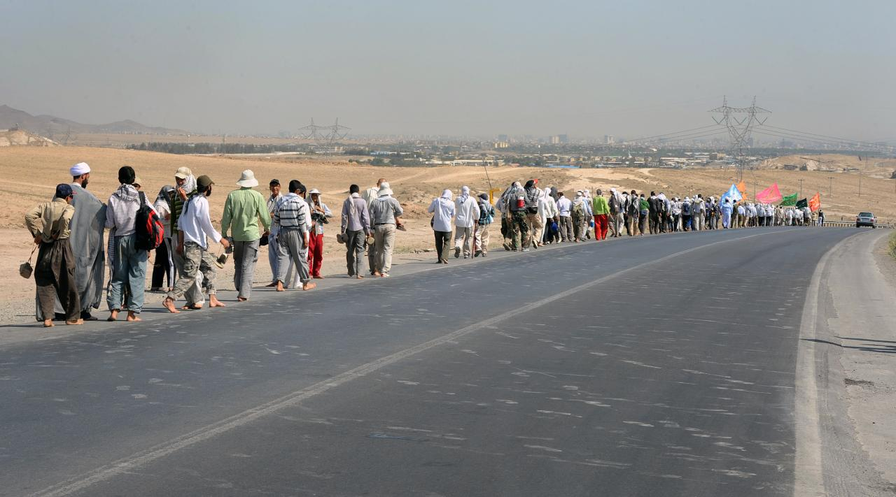
The future history books might also record that we were deprived of the use of our eyes. In our hurry to get from one place to another, we failed to see anything on the way. Air travel gives you a bird's-eye view of the world or even less if the wing of the aircraft happens to get in your way. When you travel by car or train a blurred image of the countryside constantly smears the windows. Car drivers, in particular, are forever obsessed with the urge to go on and on: they never want to stop. Is it the lure of the great motorways, or what? And as for sea travel, it hardly deserves mention. It is perfectly summed up in the words of the old song: 'I joined the navy to see the world, and what did I see? I saw the sea. The typical twentieth- century traveller is the man who always says ' I 've been there.' You mention the remotest, most evocative place-names in the world like EI Dorado ,Kabul, Irkutsk And someone Is bound to say 'I've been there' - meaning, 'I drove through it at 100 miles an hour on the way to somewhere else.'

When you travel at high speeds, the present means nothing: you live mainly in the future because you spend most of your time looking forward to arriving at some other place. But actual arrival, when it is achieved, is meaningless. You want to move on again. By travelling like this, you suspend all experience; the present ceases to be a reality: you might just as well be dead.
The traveller on foot, on the other hand, lives constantly in the present. For him travelling and arriving are one and the same thing: he arrives somewhere with every step he makes. He experiences the present moment with his eyes, his ears and the whole of his body. At the end of his journey he feels a delicious physical weariness. He knows that sound ,satisfying sleep will be his: the just reward of all true travellers.

Post-reading activities

A. True or False

……………..In the twentieth century, people forgot how to use their legs
……………..Travelling at high speeds can be pleasure in itself.
……………..When you travel at high speeds, you can see better the world.
……………..A person who travels on foot can live in the present.
……………..Man uses his intelligence to extend his abilities.

B. Mark the best choice.
1.A person who travels at high speeds……………… .
a. lives in the future
b. lives in the present
c. lives in the past

2. Traveller on foot feels a delicious weariness because……………… .
a. he can experience the present moment the whole of his body
b. he can travel on foot
c. he can see better

3. Foolish to climb a mountain for that old woman……………………… .
a. when there is a railway
b. when there is an airplane
c. when there is a bus

4. When you travel high speeds, you live mainly in the future because………….
a. you don't have time to arriving at some other place.
b. you spend most of your time looking forward to arriving at some other place.
c. you want to arrive on time.

5. If we depended on our legs, …………………… each other, as the past.
a. we would be communicated
b. we can travel more with
c. we would be isolated

C. Fill in the blanks with correct words from the list.

escalators surprising urged
mention huge evocative
experience extraordinary weariness
somewhere intelligence perfectly

1. The …………...thing is that people didn't use their legs when they went on holiday.
2. Whenever I …………....playing football, he says he's too busy.
3. She had the …………….to turn off the water at the main.
4. At the end our journey we feel a delicious …………….. .
5. Lifts, ……………in all building prevent us from walking.
6. The little child lost her toy car …………….between here and the station.
7. Men built cable railways to the tops of every……………. mountain.
8. They did an………………..effort for solving this problem.
9. The doctor didn't have enough work …………….for his job.
10. She …………. her mare to jump the fence.

Pre-reading

1-What are Beggars?
2-What are called persons who don't have homes of their own?
3-Is it possible to measure the value of material goods in terms of money?
4-Do Beggars have something to sell?
5-Are the conditions of society such that skills have to be paid for in the same way goods?
6-Does the writer seem to feel sympathy for trams?

Everyone has something to sell

It has been said that everyone lives by selling something. In the light of this statement, teachers live by selling knowledge, philosophers by selling wisdom and priests by selling spiritual comfort. Though it may be possible to measure the value of material goods in terms of money, it is extremely difficult to estimate the true value of the services which people perform for us. There are times when we would willingly give everything we posses to save our lives, yet we might grudge paying a surgeon a high fee for offering us precisely this service. The conditions of society are such that skills have to be paid for in the same way that goods are paid for at a shop. Everyone has something to sell.

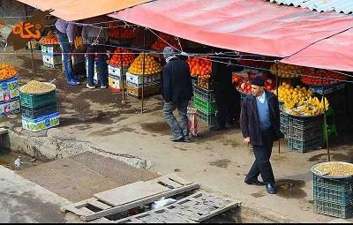
Tramps seem to be the only exception to this general rule. Beggars almost sell themselves as human beings to arouse the pity of passers-by. But real tramps are not beggars. They have nothing to sell and require nothing from others. In seeking independence, they do not sacrifice their human dignity. A tram may ask you for money, but he will never ask you to feel sorry for him. He has deliberately chosen to lead the life he leads and is fully aware of the consequences. He may never be sure where the next meal is coming from, but he is free from the thousands of anxieties which afflict other people. His few material possessions make it possible for him to move from place to place with ease. By having to sleep in the open, he gets far closer to the world of nature than most of us ever do. He may hunt, beg, or steal occasionally to keep himself alive; he may even, in times of real need, do a little work; but he will never sacrifice his freedom. We often speak with contempt for tramps and put them in the same class as beggars, but how many of us can honestly say that we have not felt a little envious of their simple way of life and their freedom from care?

Post-reading activities

A. True or False
………….A real tram never tries to arouse the pity of passers-by.
………….To keep himself alive , a tram may sometimes beg.
…….........Unlike beggars, trams seem to be satisfied with the kind of life they lead.
………….Tramps do not usually have homes of their own, so they gave to sleep in the open.
………….The writer does not seem to feel sympathy for tramps.

B. Mark the best choice.
1. A tramp doesn't…………………. .
a. ask you for money
b. work or beg or steal
c. ask you to sympathize with him

2. '…we might …………….paying a surgeon a high free…'
a. envy
b. sacrifice
c. grudge
3. Tramps seem to be interested in seeking…………… .
a. spiritual comfort
b. material possessions
c. freedom from poverty
4. 'By having to sleep in the open, he gets far closer to the world of nature than most of us ever do.'
Do substitutes…………………….. .
a. to sleep in the open
b. to get close to the world of nature
c. to sleep in the open and to get close to the world of nature
5. It is impossible to measure the value of material goods……………money.
a. in the light of
b. in terms of
c. in times of

C. Fill in the blanks with correct words from the list.
beg knowledge statement
aware estimate conditions
wisdom extremely dignity
nature afflicted deliberately
1. His …………..was clear but not beautiful.
2. He thinks it below his…………..to clean his own shoes.
3. They had to wait better weather …………before they started their journey.
4. I have always dreamed of escaping from city and back to …………… .
5. It is hard to …………….the age of some people.
6. Because of ……………heavy snow, they had to cancel the football game.
7. The two world wars ………………the Europeans with poverty.
8. He was so poor that he had to…………….for his bread.
9. Her father punished her because she had broken my glasses………………. .
10. He was so interested in his reading that he was not……….of my presence.

Pre-reading
1. How well were industrial goods made once? How long ago?
2. What has industry done too us?
3. Why don't we repair many things?
4. Why are many cares traded in?
5. What sort of society does the writer want to see?
6. What is thrown away when we buy a new article? Who pays for it?

Waste not, want not!

Sir,
Once upon a time (and not very long ago, either!) industrial goods were made to last for ever. If you bought a car or a cooker, it was a once-in-a-lifetime investment. You paid good money for the article and you looked after it. Nowadays industry has persuaded us that its products can only last a very short time. It's cheaper to throw them a way than to repair them. This had led directly throw a way society and to the waste of the earth's resources. Jus think of the cars that are traded in daily simply because they are "out of fashion". Just think of the expensive packaging material that is thrown away each time a new object is bought-material which we the consumers must pay for!
Our industrial society has turned us into spoilt children. It's this terrible wastefulness that has got us into the mess we are in now. When there are no resources left. We'll start to look after what we have. But why can't we act before this happens? Why can't we go back to a society in which the prevention
of waste is a virtue?

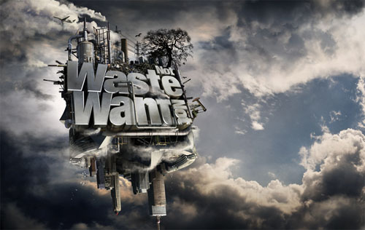

Post-reading activities
A. True or False
....................once upon a time industrial goods were made to last for ever.
....................Nowadays it is expensive to throw them away than to repair them.
....................Our industrial society has turned us into spoilt children.
....................The consumers must pay for solving the waste problem.
………...…..Prevention of waste was only one of our grand parents' virtues.

B. Mark the best choice.
1. The writer believes that we …………………..to a society in which prevention of waste is a virtue?
a. we should go back
b. we can't go back
c. we will go back
2. Why don't we repair many things? Because…………………………. .
A . It is cheaper to buy a new one.
b. It is easier to buy a new one
c. It is easy to throw them away.
3. What sort of investment did a car or a cooker use to be?
a. investment group
b. personal investment
c. lifetime investment
4. Advertisers are mainly………………….the throw-away society.
a. to blame for
b. look after
c. look for
5. Which one is the best suggestion for solving this problem?
A .waste less
b. recycle waste
c. make more things to last

C. Fill in the blanks with correct words from the list.
investment persuade throw
consumer spoilt virtue
resource afford solution
permanence recycle ever
1. Industry couldn't………..…….to produce a car which will last a long time.
2. My friend can find no solution to his financial troubles.
3. Nothing threatens the …………….. of the educational system your country.
4. The……….……...is encouraged to complain about faulty goods.
5. Your brother has had a good ……………….to look after what you have.
6. Nowadays it is cheaper to………………...a cooker than to repair it.
7. Is there any ………………. that we have left untapped?
8. How can I …………........you that I am sincere?
9. The result of this ……………….. will be shortage of world's resources.
10. He hated her friend more than ………….., when he got that letter.

References

Alexander L. G.(1968). For and against. Longman.
Alexander. L.G & Kingsbury. R.H (1968). I think you think. Longman.
Khazaee far. A& Ghazizadeh.Kh.(1370). Let's read. Entesharute ahlebeat. GHom.

